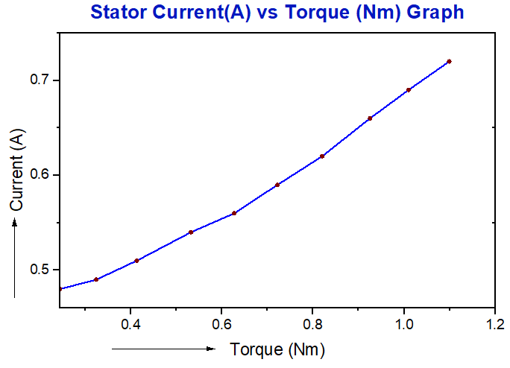

**Figure 01: Stator Current vs Torque Graph for Three phase**

**Induction motor (Four pole Squirrel Cage Rotor)**

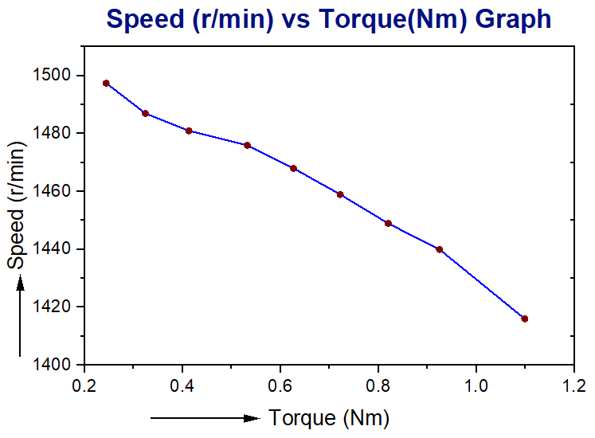

**Figure 02: Speed vs Torque Graph**

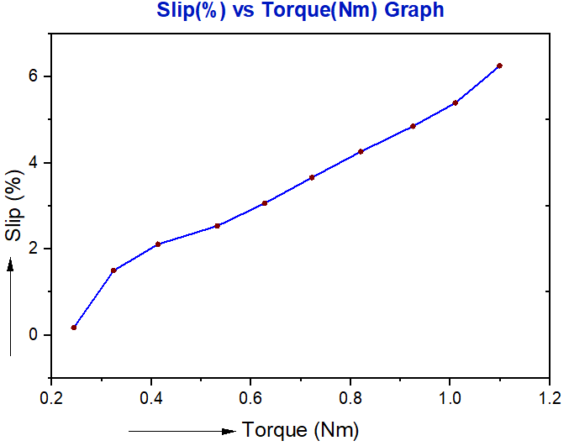

**Figure 03: Slip vs Torque Graph**

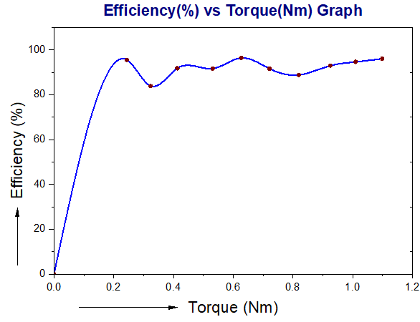

**Figure 04: Efficiency vs Torque Graph**